BE DPA 2018 Compliance for Log360

**Tagline** – Streamline BE DPA 2018 compliance with automated audit trails in Log360.
**Overview**
The BE DPA 2018 Compliance extension for Log360 helps Belgian organizations align with the Belgian Data Protection Act 2018 requirements. By integrating this extension, IT and security teams gain comprehensive visibility into their data protection posture and privacy controls.
Log360 continuously collects and correlates log data from Active Directory, Windows, Unix/Linux, Microsoft 365, cloud platforms, and network devices, mapping events directly to DPA 2018 standards. Security teams can track compliance status in real time, investigate incidents quickly, and generate audit-ready reports with a single click.

**Key Features:**
- Generate comprehensive audit-reports mapped to each of the BE DPA 2018 data protection controls and requirements.
- Automatically parses and normalizes log formats from Windows, Linux, firewalls, databases, and cloud platforms for consistent analysis.
- Analyzes user and entity behavior to detect unauthorized data access and privacy violations.
- Export reports in PDF and CSV format for auditors, management, or regulatory submissions.

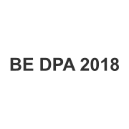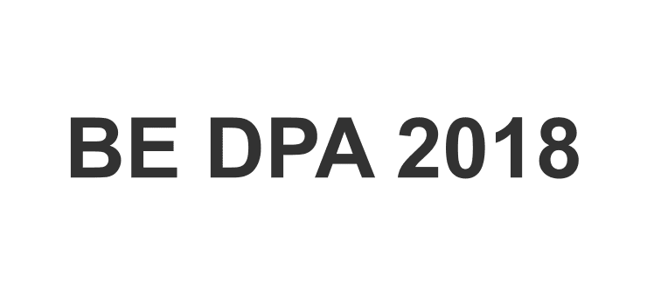
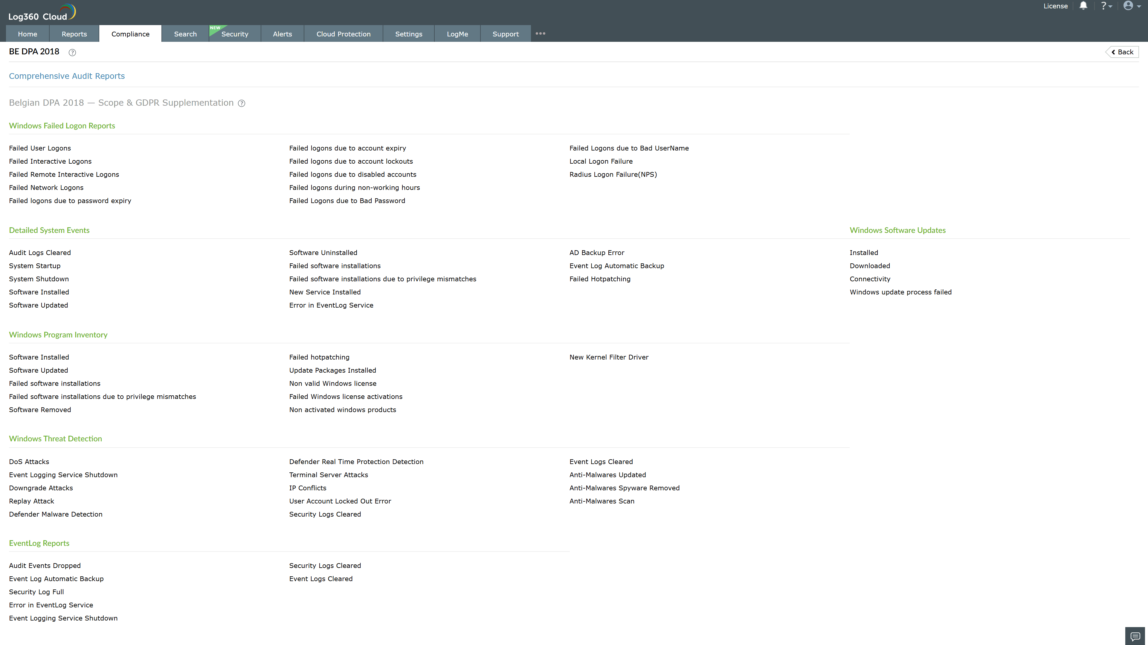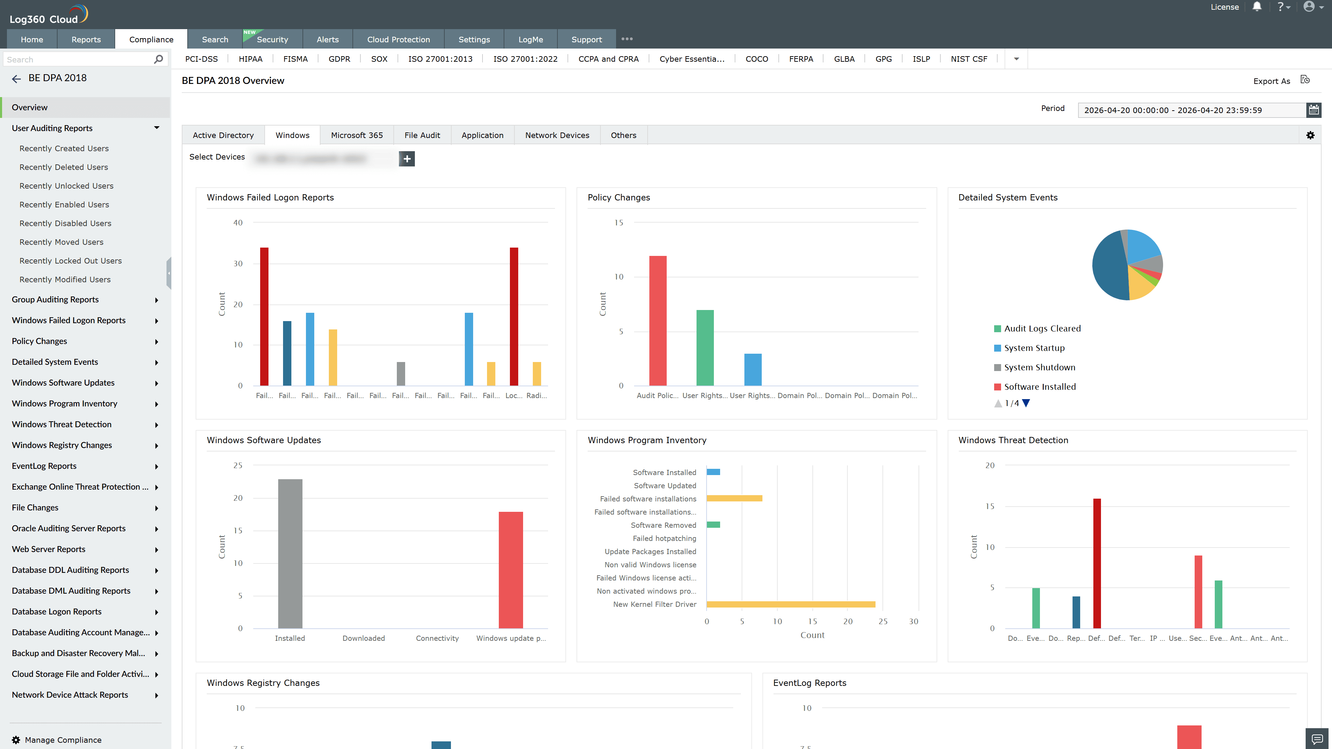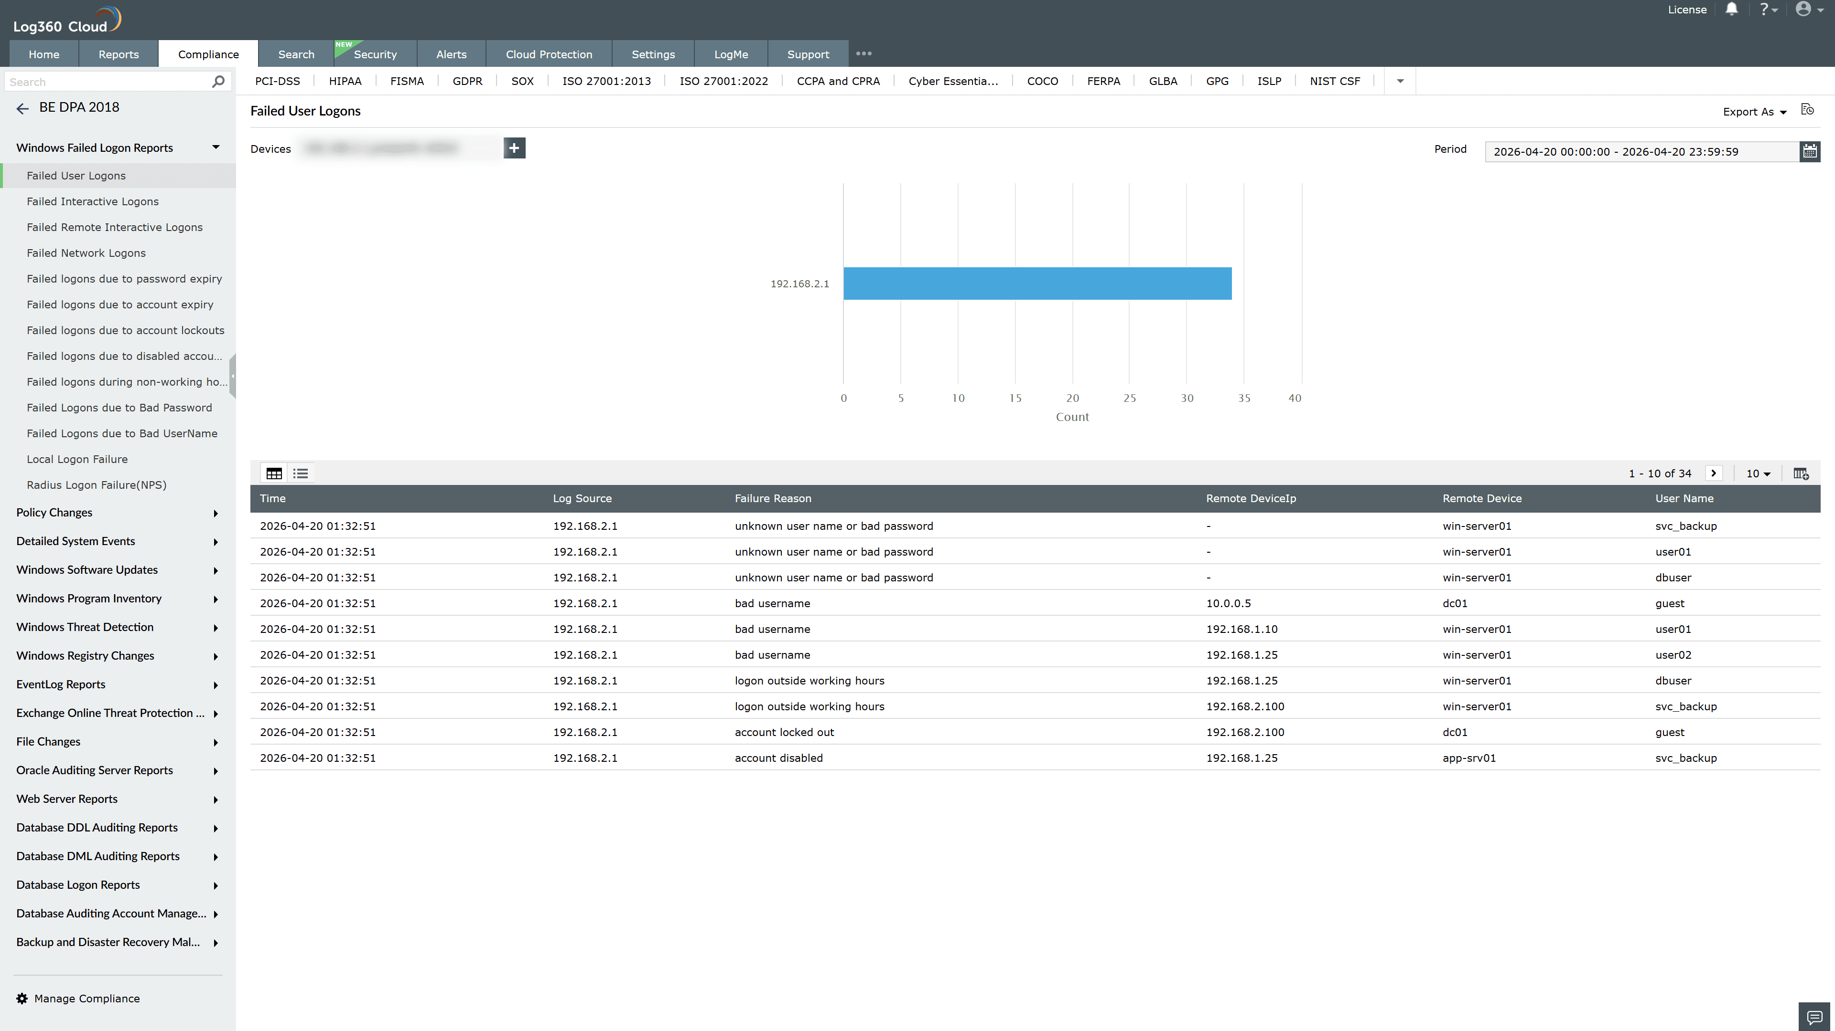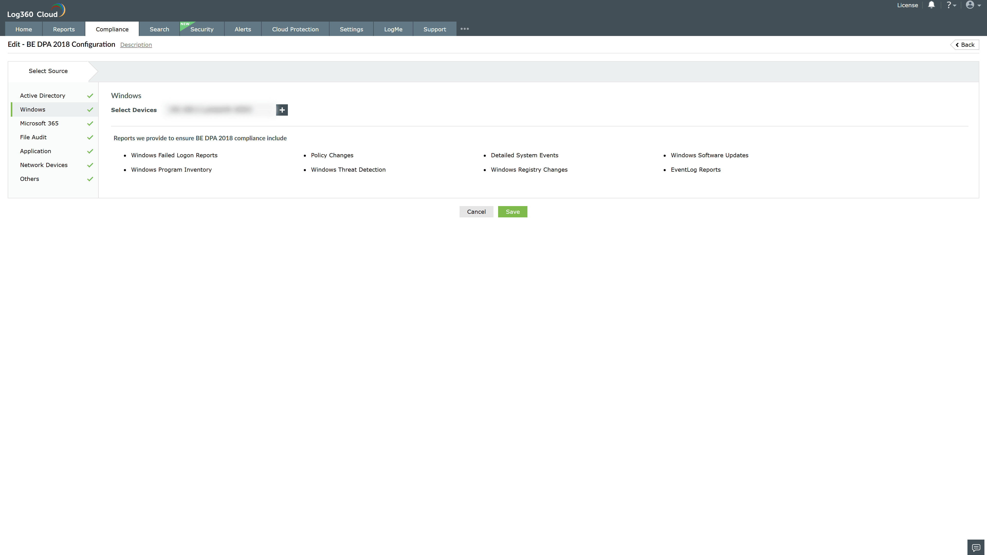
Valid Submission : Yes
Supported Editions : Free, Basic, Standard, Professional, MSSP
Help Document : https://www.manageengine.com/log-management/help/integrations/compliance-extensions.html
Help Video : Not provided
Tags : Log360, Compliance, Privacy monitoring, Data privacy, Regulatory compliance
Supported DCs : US, IN, JP, CA, AU, UK and EU
Privacy Policy:
Terms of Service:
Release Notes:
Predefined reports for the BE DPA 2018 Compliance.

